Appendix A

GB Training Organisation GBT is a training organisation that provides various training courses. The company has decided to put all the information they now keep manually into a database and to include course booking, accommodation booking, trainer allocation and room allocation in this new database.

**Background**

Students can apply for any of the courses provided. Each course has one or more trainers who are skilled in providing that course. A trainer is allocated to each course occurrence (actual course). If students attending a course require accommodation for the duration of the course, then accommodation is provided in local boarding houses which are booked by GBT and added to the overall cost of the course. They also keep a record of which students are booked into which boarding house and on which dates.

**Current System**

There is no standard method of receiving course applications. They can be made by telephone, letter or through a Course Application form which is issued with the Course Catalogue. If a student makes a general enquiry about a course, then the Student file is checked to see if he/she is a current student. If a student is not in the Student file then he/she is sent a Student Details form to complete together with the Course Application form. When the students return their Student Details form they are allocated unique student numbers and the students’ details are then added to the Student file.

**Course Booking**

Upon receipt of a valid course application the Current Course file is checked for a vacant place on a currently organised course (actual course). If there is a place available, then the student is allocated to that course (actual course) and notification details are sent to the student.

If there is not a place currently available on a Current Course, students are allocated to the Type of Course they wish to attend. When there are enough students waiting to attend a course then a new actual course is set up and students waiting for that course are sent notification details and allocated to a Current Course (actual course).

When a student is notified of his/her acceptance onto a course, possible accommodation details are sent out and an accommodation booking is subsequently made, if required.

A training room is allocated to an actual course by the Course Booking Section. Only one room will be allocated for each course run. The training room list is checked for available rooms, an available room is allocated and the room list is updated. Trainers are then allocated to the actual course. The system must check which trainers are qualified to teach that particular course and which trainer is currently available to be allocated to the course

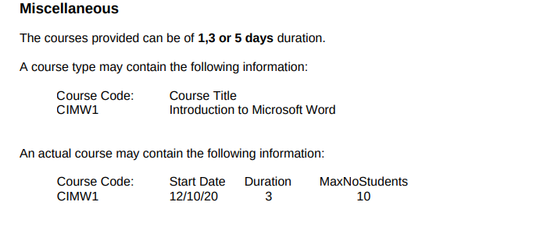

Database design Implementation

**GB Training Organisation**

GBT is a training organisation that provides various training courses. The company has decided to put all the information they now keep manually into a database and to include course booking, accommodation booking, trainer allocation and room allocation in this new database.

**Courses**

GBT training offers Various courses which is handled by a particular trainer. The courses when in session are called Current (actual) courses. Students are then allocated to the current course if the maximum number of students needed has not been reached or they are added to a waiting list if the class limit has been reached. The students can apply to:

* Students can apply to any of the courses provided and they can apply for more than one course
* A valid course application checks for vacant place on currently organised courses called “actual course”
* A course can have multiple ongoing current courses
* Student are allocated through course allocation if the limit for the current course has not been reached and they are sent a notification with their details.
* A course can have a waiting list if maximum number for its current courses has been reached. If the number of students in the waiting list reaches the minimum for a new current course a new course allocation is done for a current course and students on the waiting list are added to the new instance of the current course.

Details are recorded for each course are listed below:

* Course code
* Course Title
* Current(actual) Course code
* Course registration
* Course Waiting Number
* Course duration
* Course Allocation ID
* Number of students required for a new current course
* Maximum number of students per current course
* Course fee
* Courses start date
* The students in the waiting list and their course details

**Student Records**

GBT training has a list of students holding their details. The record holds details of students who are currently enrolled or have made enquiries about courses. GBT holds students holds information of both allocated students and non-allocated.

* Students can make enquiries about a course
* Student is sent an application form if they are not present in the student records
* Students are allocated unique ID and details added to their student files
* Students are assigned to a current course through course allocation if the maximum for students in the current course has not been reached
* Students can have many course allocations and they can be placed on waiting list if no current course is available for their course type of choice.

Details are recorded in the student files are listed below:

* Student Name
* Student ID
* Student Enrolment status
* Student Address
* Student Allocation ID
* Room Booking
* Course Fee
* Room ID

**Accommodation**

GBT training offers Accommodation for its students for the duration of their courses. An allocated student is sent offer for possible accommodation, the student can decide to book for a room or not. The allocation is usually in one of the Boarding houses booked by GBT:

* Accommodation is provided in local boarding houses booked by GBT
* The cost of the accommodation is added to the overall course
* There is a record for all students booked into a boarding house and the dates of onboarding
* A student can decide to take the accommodation or decline the accommodation offer.

Details recorded for Accommodation are:

* Room ID
* Student details
* Boarding house ID
* House Number
* Move in dates
* Duration of the stay
* The room availability

**Training Room**

GBT training has a training room Booking system. A training room is assigned to each current course. The training room is marked as unavailable for the Current course session which it has been allocated to and can be assigned to another current course in a different current course session:

* A training room is allocated to an actual course through the course booking system
* One room can be allocated to one actual course run.
* Training room has a list for training room availability
* A training room can be used by many current courses at different time periods

The training room holds details such as:

* The training room ID
* The availability of the training room. If it is available or not

**Trainers**

GBT has trainers who are responsible for taking the students through the courses.

* Only a trainer skilled in the course can teach the course.
* A trainer can be skilled in more than one courses
* A trainer needs to be available to be allocated to an actual course.
* A trainer can teach more than one current course at different course sessions

Details about the trainer are kept:

* Trainer name
* Trainer ID
* Trainer skills
* Trainer availability for the current course

**The Entities and Entity Description**

* **Course Type** – This is the type of course the student can apply to such as Marketing, Programming or Pottery.
* **Student Records** – This entity holds details of the students that have made an enquiry about the course types offered by GBT.
* **Course Allocation** – This holds information about the different ongoing courses and students enrolled in it. There could be multiple course allocations for the same course type.
* **Allocated Students** – This holds information about students who have been successfully granted a place in one or more of GBT’s Current courses
* **Current Courses (Actual courses)** – This is a table that contains information about the actual course types, a current course has a attribute that keeps count of the number of instances of a particular course type.
* **Room Allocation** – This holds information about the different rooms that have been allocated within a particular boarding house to students.
* **Training Rooms –** This table has information about the rooms allocated for training.
* **Boarding Houses –** This holds information about all the Boarding houses available for lodging and the rooms in them.
* **Trainer –** This holds information about the skill type and the GBT training personnel. It shows their skills and whether they are allocated or free to take on a new allocation.
* **Waiting List–** This holds information about the students waiting to be enrolled into a current course when the minimum number needed has been reached.

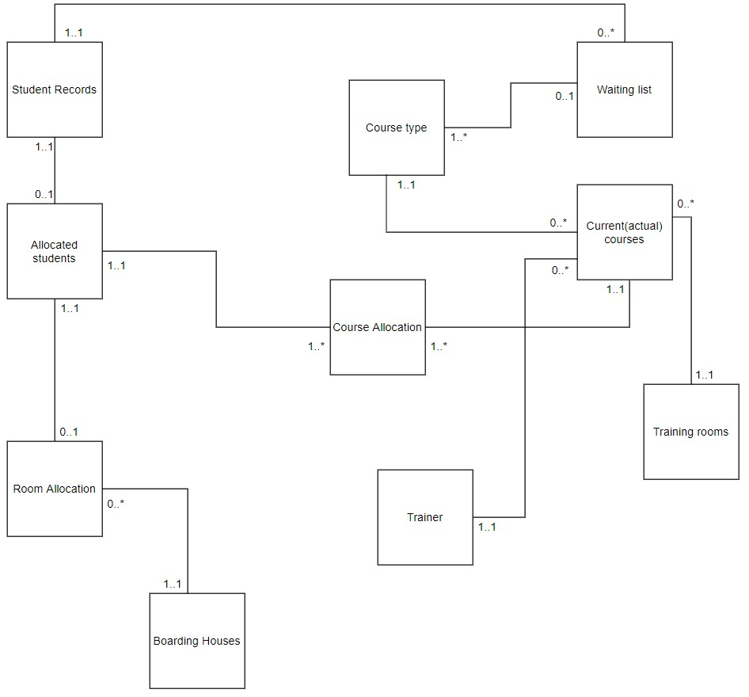

**Assumptions**

The assumptions below form the base for the ERD for GBT’s new system. The ERD has been built with all required linking relationships. The assumptions below form the basis of understanding the business rule for the new system. It helps understand the requirements and ensuring correct and accurate relationships between entities.

* **Student Records to Waiting List**– This is a one to many relationships since a student can apply to one or many courses on the course list through applications hence, they can be in waiting list for more than one course. Student Records has an optional participation as a student can exist without being on the Waiting list for a course. The Waiting list on the other hand has a mandatory participation because a course application cannot exist in the database without a student attributed to Waiting ID on the queue. This is a Default Participation.
* **Student Records to Allocated Student**– This is a one to one relationship as a student can be allocated just once in the database, an allocated student can have only one related entry in the student records showing they are a student. Student Records has an optional participation since it can exist without having a related allocated student. The list of allocated students must have a related Student Records to that allocation, and this means it has a mandatory participation. This is a Non-Default Participation.
* **Allocated student to Room allocation** - An allocated student can have only one room allocation; a room allocation can have only one related allocated student which makes this a one to one relationship. An allocated student can exist without a room allocation since they can decide to lodge into the room offered or decide not to which makes this an optional participation, if an instance of room allocation exist it must have a related allocated student which means this has a mandatory participation. This is a Non-Default Participation.
* **Boarding house to Room Allocation** – This is a one to many relationship. A room allocation can be to only one room within a boarding house, a boarding house can have none or many room allocation since we can have a boarding house without anyone checking into it which is unlikely since GBT books the boarding house on request. A room allocation cannot exist without a related boarding house which makes this a mandatory participation, a boarding house can exist without a room allocation which means no one lodged into any of the rooms in this boarding house this makes this an optional participation. This is a Default Participation.
* **Allocated student to Course allocation** - An allocated student can have many course allocation since one student can be taking many courses, a course allocation can have only one student related to that instance of allocation which is a one to many relationship. Allocated student cannot exist without a related course allocation (mandatory participation), An instance of course allocation cannot exist without a related student (mandatory participation). This is a Non-Default participation.
* **Course type to Waiting List**– This is a one to many relationship, A course type can have many related course applications to it from different students and as such can have many students on its waiting list. The Course Type can exist without a Waiting list which makes it an optional participation. The Waiting list cannot exist without a related course type hence this is a mandatory participation. This is a Default participation.
* **Course type to Current Courses** - A Course type can have one or many related Current courses, a current course can have only one course type which makes this a one to many relationships. A Course Type can exist without a related Current course which makes it an optional participation, but a current course cannot exist without a related course type which is a mandatory participation. This is a Default participation.
* **Current course to Course allocations** – This is a one to many relationship. A Current course can have one or many course allocations due to the fact that we can have the same course ongoing at different allocations(sessions), a course allocation can have only one current course related to it. A current course cannot exist without a course allocation which is a mandatory participation, a course allocation cannot exist without a related Current course to it which is also a mandatory participation. This is a Non-Default participation.
* **Training rooms to Current Course** – This is a one to many relationship, a Current course can have only one associated training room because once a training is in session the session can be held in just one room. A training room can have many assigned current course at different course allocations. A Current course cannot exist without a related Training room allocated to it which is a mandatory participation, a training room can exist without a related course allocation which is an optional participation. This is a Default Participation. A training room without a related course allocation is considered free.
* **Trainer to Current Course** – This is a one to many relationship. A Current Course can have only one assigned trainer, a trainer can be allocated to one or many Current Courses at different Course Allocation session. A Current course cannot exist without a trainer which is a mandatory Participation, A trainer can exist without related course allocations which is an optional Participation. This is a Default Participation.

**Keys and Data Type**

The entities and relationships for GBT has been sorted out, we will now create the attributes, primary keys and Foreign keys. We will find the primary identifier for each of the entities and the foreign keys for entities with relationships between them. This will be shown in the diagram below.

